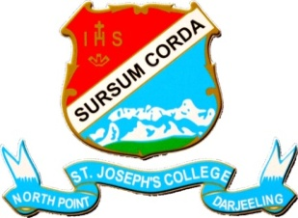

St. Joseph’s College Faculty Details Page on Web-site
 | Title | First Name | Last Name | 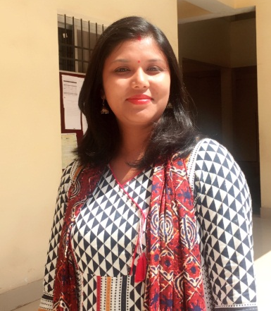
Name | Dr. | Rajani | Dewan
Designation | Assistant Professor
Educational Qualification | M.Sc., Ph.D.
Date of Joining | 02.05.2015
Department | Department of Chemistry
Address
Local | Marian Road, Near Dhanu Cottage,  Dhobitala, Darjeeling 734101
Permanent | Same as above
Phone Numbers
Office
Residence | 8145611106
Email | dewan_rajani@yahoo.com
Fax
Teaching Experiences  (Present & Previous) | Four years and seven months
Research Interests | Electrochemistry/Solution thermodynamics
Awards
Professional Achievement
Administrative Responsibilities | 1. NCC Coordinator,  2. Coordinator of the Cultural Committee  3. Member of the Women Empowerment and Anti-Harassment Cell  4. Incharge, Department Library
Publications
In Journal | - MahendraNath Roy, PrasannaPradhan, RajaniDewan, ‘Fluid Study on ion–solvent interactions of alkali metal salts in pure methanol and it’s binary mixtures with ethane-1,2-diol by a conductometric technique’. Fluid Phase Equilibria, 282 (2009) 51–57  - MahendraNath Roy,RajaniDewan, Lovely Sarkar, ‘Ion-Solvent Interactions of Some Halides of Common Cations with Organic Solvent Mixtures by Conductometric, Volumetric, Viscometric, and Refractometric Techniques’. J. Chem. Eng. Data, 55 (2010)1347–1353.  - MahendraNath Roy,Lovely Sarkar, RajaniDewan, ‘Molecular interactions with reference to manifestation of solvation effects in binary mixtures of ethyl acetoacetate with some methane derivatives by physicochemical techniques’. Bull. Chem. Soc. Ethiop. 24(1) (2010) 001-012.  - MahendraNath Roy,RajaniDewan, Pran Kumar Roy, DebabrataBiswas, ‘Apparent Molar Volumes and Viscosity B-Coefficients of Carbohydrates in Aqueous Cetrimonium Bromide Solutions at (298.15, 308.15, and 318.15) K.’J. Chem. Eng. Data 55 (2010) 3617–3624  - MahendraNath Roy, DebabrataBiswas,Lovely Sarkar, RajaniDewan, ‘Solution properties of binary mixtures of 2-butoxy ethanol with some alkanols and alkanoates’. J.T.R. Chem 17(1) (2010)1-14  - MahendraNath Roy,Lovely Sarkar, RajaniDewan, ‘Ion-pair and triple-ion formation of some tetraalkylammonium iodides in n-hexanol and its binary mixtures with o-toluidine’ J. Chem. Thermodynamics 43 (2011) 371–376  - RajaniDewan, MahendraNath Roy, ‘Ion-pair and triple-ion formation in low permittivity solvent: a conductometric study’ J. Phys. Chem Liq. 49 (2011) 145–154  - MahendraNath Roy, Deepak Ekka,RajaniDewan, ‘Ionic solvation of tetrabutylammoniumhexafluorophosphate in pure nitromethane, 1,3-dioxolane and nitrobenzene: A comparative physicochemical study’Fluid Phase Equilibria314 (2012) 113– 120  - MahendraNath Roy, Deepak Ekka,RajaniDewan, ‘Physico-Chemical Studies of Some Bio-active Solutes in Pure MethanoicAcid’ActaChim. Slov. 58 (2011) 792–796.  - RajaniDewan, MahendraNath Roy, ‘Physico-chemical studies of sodium tetraphenylborate and tetrabutylammoniumtetraphenylborate in pure nitrobenzene and nitromethane and their binaries probed by conductometry, refractometry and FT-IR spectroscopy’ J. Chem. Thermodynamics 54 (2012) 28–34  - MahendraNath Roy, RajaniDewan, Deepak Ekka, IshaniBanik, ‘Probing Molecular Interactions of Ionic Liquid in Industrially Important Solvents by Means of Conductometric and Spectroscopic Approach’ ThermochimicaActa559(2013)46-51  - RajaniDewan, BiswajitDatta, Milan Chandra Roy and MahendraNath Roy, Ionic interplay of lithium salts in binary mixtures of acetonitrile and diethyl carbonate probed by physicochemical approach. Fluid Phase Equilibria, 358 (2013) 233-240  - MahendraNath Roy, Milan Chandra Roy, SubhankarChoudhury, Pran Kumar Roy and RajaniDewan, ‘Conductometric, refractometric and FT-IR spectroscopic study of [EMIm]NO₃, [EMIm]CH₃SO₃, and [EMIm]OTs in N,N-dimethyl formamide, N,N-dimethyl acetamide and dimethyl sulphoxide’ ThermochimicaActa599(2015)27-34.  - Biraj Kumar Barman, Deepak Ekka, RajaniDewan and MahendraNath Roy, ‘Investigation of Diverse Interaction of Lithium Hexafluoroarsenate Prevailing in Pure and Mixed Industrial solvent systems by Physicochemical Methodology’ Indian Journal of Advances in Chemical Science 5(4)(2017)285-294
Chapter’s in Edited Volume
Book Monograph/ Edited Book
Report
Paper Presentations | - Presented Paper in National Seminar on Frontiers in Chemistry 2011 and Celebration of the International Year of Chemistry 2011 on March 14-16, 2011 sponsored by University Grants Commission, New Delhi, India and University of North Bengal organised by the Department of Chemistry, University of North Bengal, Darjeeling.  - Presented a Paper in National Seminar on Impact of Technology on society: Issues and Challenges organized by St. Xavier’s College, Patna; St. Xavier’s College of Management & Technology, Patna and Xavier Institute of Social Research, held at St. Xavier’s College on 12th -13th April, 2014.

